Maximum Marks

4 Marks

Retailers

Project Name

Project – Inventory Management for

**Technical Architecture:**

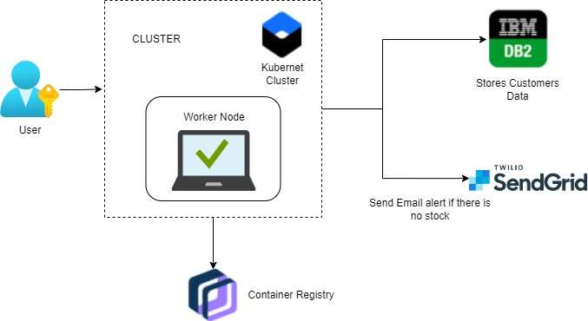

16 October 2022

Date

**Technology Stack (Architecture & Stack)**

**Project Design Phase-II**

PNT2022TMID32730

Team ID

File Storage

Requirements to store files

IBM Block Storage or Other Storage

Service or Local File system

8.

External API-1

SendGrid used in application will send the email

SendGrid

alert if there is less number or no stock to the user

9.

6.

Cloud Database

IBM DB2.

Information of the stocks will be stored and hosted

on the cloud.

7.

Application Deployment on Local System / Cloud Local

11.

Infrastructure (Server / Cloud)

Local, Cloud Foundry, Kubernetes, etc.

Server Configuration:localhost:5001(Flask)

Cloud Server Configuration : Kubernetes

External API-2

IBM container Registry enables you to store and

IBM container registry

distribute Docker images in a managed private

registry

10.

Machine Learning Model

Purpose of Machine Learning Model

Object Recognition Model, etc.

HTML, CSS, jQuery, JavaScript, python,

Through web application, the information processed will

be

sent to the user via mail.

etc.

**Table-1 : Components & Technologies:**

2.

**S.No**

**Component**

**Description**

**Technology**

1.

User Interface

5.

Application Logic-3

User will get notified about the stock status.

Flask

4.

Database

The data can be stored in database and user can

IBM DB2.

retrieve or manipulate the data whenever

required.

3.

Application Logic-1

Flask, SendGrid

User registration through form and confirmation will be

sent to the user via email.

Application Logic-2

Flask

Dashboard is used by which the system will

Maintain tracking of sales of product and inventory levels.

for premium user news, database and price alert will

4.

Availability

Prediction will be available for every user but only

Flask.

be alert.

that the quite amount of storage is satisfied.

Scalable Architecture

It is scalable that we are going to use data in kb so

Flask

5.

Performance

Flask, IBM container registry, IBM DB2.

It will perform fast and secure even at the lower

bandwidth.

**Description**

**Technology**

1.

Open-Source Frameworks

**Table-2: Application Characteristics:**

SendGrid will send email alert, if there is less number

**S.No**

**Characteristics**

IBM container registry.

We use login for the user and the information will

be hashed so that it will be very secure to use.

3.

Flask, SendGrid, IBM DB2,

of stock to user, Kubernetes for manipulating

Kubernetes

Kubernetes API objects, IBM DB2 is used

for storing and retrieving the data efficiently.

2.

Security Implementations